To whom it may concern

This is to certify that ………………………………………………………………….
has enrolled as a student at the Bulgarian Sunday school in Bournemouth/Portsmouth named “Vasil Aprilov”.
The lessons take place every Sunday 9.30am – 2.30pm.

“Vasil Aprilov” School is certified by the Bulgarian Ministry of Education and is regulated by Government Decree No.90/2018 of Republic of Bulgaria.

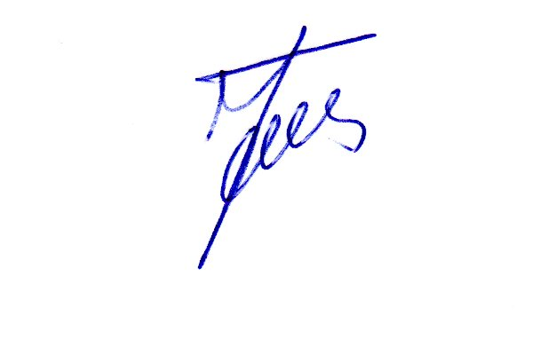

Maya Nikolova-Toms 06/11/2020
Headteacher
“Vasil Aprilov” Bulgarian School


